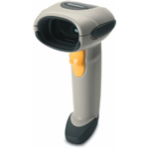

Symbol Scanner LS4208

Accelerate throughput with productivity-enhancing features never before seen from a Symbol scanner
Designed to increase process efficiencies in scan-intensive operations, the LS4208 handheld bar code scanner speeds data capture by reading bar code information in one pass. It helps you increase productivity with a unique array of features not found in other available scanners, including an innovative multi-line rastering scan pattern, wide working range and superior motion tolerance. With the LS4208, novice and advanced users alike will be able to rapidly and accurately scan all types of one-dimensional (1D) bar codes, including damaged symbols or stacked reduced space symbology (RSS) bar codes. As your productivity increases, you’ll require fewer resources to capture more data in less time.

